Licensed for Life: Botched Abortions Lead To $6.2 Million Payout
By William Heisel
May 09, 2012
As physicians age, they shift their focus to treatments and procedures that compensate for their deteriorating physical and mental health, Dr. William Norcross told Antidote recently.
Or, as Antidote found during The Shadow Practice series, these doctors make their way to back alley clinics and painkiller mills where they end up hurting patients.
Dr. Lawrence Hansen, now 87, was part of a two-surgeon tag-team that performed a series of plastic surgeries on Maria Garcia in 2008. Her vaginal wall was punctured during Hansen's surgery, and she bled to death while being operated on by Dr. Harrell Robinson, another aging physician.
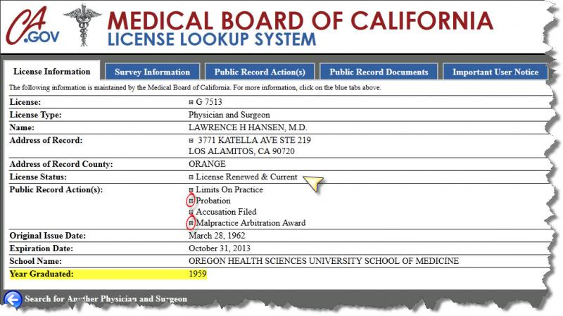
Hansen had been looking for a way to supplement his retirement income when another physician retiree recommended he work at the Hills Surgical Institute in Anaheim Hills. As Antidote wrote before, by the time Hansen saw Garcia in March 2008, he was 83 years old and had not performed a vaginal rejuvenation procedure – or vaginoplasty – since 2003.
Hansen operated on Garcia in an unlicensed clinic. He used anesthesia in a way that violated state legal codes. He did so in an environment without the proper safety precautions in place. Yet, the Orange County coroner ruled the death a "therapeutic misadventure." Garcia's family sued, and that case is ongoing.
Six months after Garcia's death, patient Luz Escalante sued Hansen – along with two other doctors – over two botched abortion procedures.
You read that right. Escalante went to Hansen and his colleagues for an abortion, and they did the procedure wrong. Twice.
Here's what happened, according to the lawsuit:
In August 2007, Escalante went to Hansen's clinic, run by Family Planning Associates Medical Group, in Long Beach. She was about one-month pregnant, and she asked for an abortion.
Hansen, Dr. Ruben Marmet, and Dr. Soon Chon Sohn performed an abortion on Escalante that day. Hansen wasn't the only senior physician in this group. Marmet is now 74, and Sohn is 70.
As the lawsuit alleges, the doctors "negligently, carelessly and recklessly performed the abortion procedure on August 13, 2007 such that it failed to terminate the pregnancy."
So Escalante returned to the clinic in September 2007. The lawsuit says, "Again, Defendants so negligently, carelessly and recklessly performed the second abortion procedures such that it also failed to terminate the pregnancy."
They entered into arbitration with Escalante in 2011. Sohn was dropped from the case. In January 2012, Los Angeles Superior Court Judge Robb M. Klein ruled in favor of Escalante and against Family Planning Associates and the two remaining doctors – Hansen and Marmet. He ordered them to pay $6.2 million to Escalante.
Hansen must have good insurance, because the lawsuit and multi-million dollar judgment did not stop him from practicing.
Original article found online at: http://www.reportingonhealth.org/blogs/2012/05/09/licensed-life-botched-abortions-lead-62-million-payout

