Ambulance at St Paul PP / Pro-life Action ministries
St. Paul, Minn. Another ambulance has been recorded at the mega-Planned Parenthood (PP) abortion facility in St. Paul. Photos taken from grainy video clearly show an ambulance stopped to unload at the nearest entrance to PP and then directed by PP officials to the main entrance deep in PP's compound far from the street where it was loaded. A young woman was seen driving out following the ambulance when it left, presumably the friend of an abortion client.
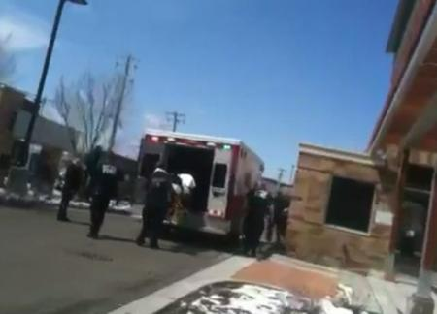
Brian Gibson, Executive Director of Pro-Life Action Ministries, said, “Planned Parenthood wants no one seeing its victims in order to maintain a public impression that abortion is safe for the woman. Yet, here we have another ambulance at Planned Parenthood's brand new fancy abortion mill.
“Ironically,” said Gibson, “I opened a message this morning from the Planned Parenthood Minnesota, North Dakota, South Dakota Action Fund begging supporters to work to stop legislation that would require Planned Parenthood and all abortion providers in Minnesota to comply with the same standards as all other out-patient surgical centers. It also comes on the heels of the dismissal of nine charges against Kermit Gosnell, the notorious 'House of Horrors' abortionist in Philadelphia. Planned Parenthood claims it wants abortion to be safe and legal. Yet the only ones they want abortion to be safe and legal for are Planned Parenthood and its abortionist. After the babies, Planned Parenthood leaves the women to last,” stated Gibson.

