Dr. Mark A. Knight, Anaheim Hills Plastic Surgeon Accused of Sexy Time With Patients and Botched Surgeries, Surrenders His Medical License
By Matt Coker Fri., Dec. 10 2010 at 11:23 AM

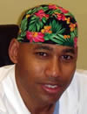
​

We pointed you earlier this month to the excellent reporting of the Los Angeles Times' Molly Hennessy-Fiske, who has exposed the non-regulation of California cosmetic surgery centers, including some in Orange County.
Now comes word that one plastic surgeon under the unfriendly glare of the media and the state medical board, Dr. Mark A. Knight, co-owner of the Anaheim Hills Surgery Center, has agreed to surrender his license amid accusations he kissed and massaged one female patient getting a post-op exam and had sex on an exam table with a second patient, whose husband walked in on them.
The medical board, which on Thursday accepted the offer by Knight and his attorney to surrender the doctor's medical license, had been investigating him since April for alleged sexual misconduct, abuse, negligence, dishonest or corrupt acts and failure to maintain medical records, Hennessy-Fiske reports here.

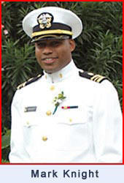
Anaheim Hills Surgery Center
​

Read the complaint here.
In addition to the post-op incident with the 36-year-old woman in November 2007 and the sex exam with the 32-year-old tummy tuck patient in January 2009, Knight within the past three years had been sued by the families of two women who died of blood clots following cosmetic surgeries he performed at other Orange County facilities. One suit is in arbitration and the other was dismissed, Hennessy-Fiske reports.
Knight reportedly took over a penile enhancement business at Anaheim Hills Surgery Center after another doctor there surrendered his license to resolve medical board accusations of negligence and incompetence. That makes three Anaheim Hills Surgery Center doctors who have surrendered their medical licenses since September 2009.
A fourth surgeon there, 85-year-old Dr. Lawrence Hansen, is fighting medical board accusations that he botched a 2008 vaginoplasty that left a 39-year old mother of five dead from what coroner's officials deemed was an accidental puncture wound.

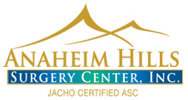
​

Hennessy-Fiske's coverage has exposed a quirk in California law: while doctors must be licensed to practice, surgery centers like Anaheim Hills that are owned in part by such a doctor do not have to be state licensed, and if they do not accept federal health insurance, the centers do not have to be state certified.
Anaheim Hills Surgery Center is neither, and now that Knight has surrendered his license, the search is likely on for a new doctor to step into an ownership role so it can continue to avoid that layer of regulation.
Original document found online at: http://blogs.ocweekly.com/navelgazing/2010/12/dr_mark_a_knight_sex.php

