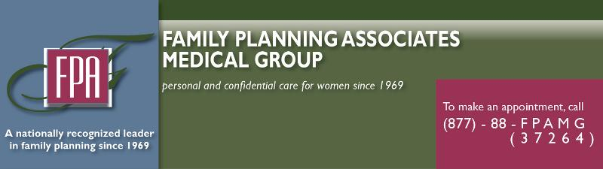

Newsletter
April 2012

A message to fellow providers, referrers, and friends:

I am pleased to announce another FPA office opening! In this month's newsletter, you will find information on FPAMG's new office that will be opening in May of 2012 in Temecula, CA as well as two informative articles involving women's health.

"New Birth Control Labels Detail Increased Risk for Blood Clots" is an informative article about the FDA's decision to include more detailed information on the labels of popular birth control medication. The labels provide clearer information on the risk of blood clots for those using certain brands of birth control containing drospirenone.

The article "Mississippi Governor Signs Bill Tightening Restrictions on Abortion", is about a new bill in Mississippi requiring physicians performing abortions to be board-certified obstetrician-gynecologists; passing this bill could force the state's only abortion clinic to close.

As always, I hope you find this newsletter both interesting and informative.

Irving M. Feldkamp IV, MD
President

Family Planning Associates Medical Group Expansion: Temecula, CA.

FPA is expanding and our newest office is opening in May of 2012 at 28991 Old Town Front Street, Suite #103, Temecula, CA. This spacious 1,111 square foot office will be open Monday through Friday, 9:00 AM - 5:30 PM and is now scheduling appointments.

FPA offers patients easy access to quality care through our conveniently located clinics; we are often able to see patients within only a matter of 1-2 days from the time an appointment is requested. If you have any questions about referrals or are in need of an appointment feel free to call (951) 695-5471.
28991 Old Town Front Street, Suite # 103
Temecula, CA 92590

New Birth Control Labels Detail Increased Risk for Blood Clots

By RedOrbit Staff

April 11, 2012 <RedOrbit.com>

The US Food and Drug Administration (FDA) has begun to add information to labels of popular birth control medications to warn about the increased risk of blood clots. Bayer AG's "Yaz" or Yasmin is one of the medications receiving the new label, though all common types of birth control pills increase a woman's risk of potentially fatal blood clots. The FDA is following up new studies with these labels, saying certain forms of birth control like Yaz show an even higher increase for blood clots. Yaz contains a synthetic hormone known as drospirenone which has been shown to increase the potential for blood clots.

In a statement, the FDA said, "The revised drug labels will report that some epidemiological studies reported as high as a three-fold increase in the risk of blood clots for drospirenone-containing products ... whereas other epidemiological studies found no additional risk." In their own study, the FDA found 10 in every 10,000 taking pills with drospirenone would get one blood clot per year, compared to only 6 in 10,000 women. These blood clots become fatal if they break loose and travel up to the brain, heart, or lungs. Despite these risks, women may still be on the safe side by taking the pills; The FDA noted women who become pregnant are even more likely to get these blood clots.

Find the full article at http://www.redorbit.com/news/health/1112511659/new-birth-control-labels-detail-increased-risk-for-blood-clots/

Mississippi Governor Signs Bill Tightening Restrictions on Abortion Providers

By CNN Wire Staff

April 17, 2012 <CNN.com>

(CNN) -- Mississippi's governor has signed into law a bill requiring physicians performing abortions in the state to be a board-certified obstetrician-gynecologist and to have admitting privileges at an area hospital.

"I believe that all human life is precious, and as governor, I will work to ensure that the lives of the born and unborn are protected in Mississippi," Gov. Phil Bryant said in a statement Monday. He has previously expressed his desire that the state become "abortion free."

Seven other states require abortion providers to have hospital privileges, but no other state requires that an abortion provider be an OB/GYN, said Elizabeth Nash, state issues manager for the Guttmacher Institute in Washington.

Though the 1973 Supreme Court landmark decision in Roe v. Wade made abortion legal in all 50 states, Mississippi's law could make the state the first where no abortions could be performed, she said. "It's an attempt to eliminate access without taking on Roe directly."

Mississippi has only one abortion facility, Jackson Women's Health Organization. Should it close, Mississippi women seeking abortions would have to leave the state. The clinic's owner, Diane Derzis, said in a telephone interview this month that all her doctors are obstetrician-gynecologists, but only one has admitting privileges at an area hospital. She vowed to fight to remain open.

"We are going to do everything we can to remain there ... we are not going to let the women of Mississippi down," said Derzis.

Find full article at http://www.cnn.com/2012/04/17/politics/mississippi-abortion/index.html

Original article found online at: http://myemail.constantcontact.com/April-2012-E-Newsletter.html?soid=1103672330388&aid=GuvSCTi6Ttw

