Family, friends to run half-marathon in California

Print Email
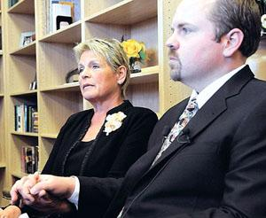
Courtesy photos Pam Feldkamp holds the hand of her son, Buddy Feldkamp, at the memorial service for the Pullen family in April 2009. They will run in a Southern California marathon on Sunday, along with Maggie Cotton, another daughter of Pam Feldkamp, in memory of the 14 people who died in the Butte plane crash. Pam Feldkamp lost two daughters, two sons-in-law and five grandchildren in the crash.
February 05, 2010 12:00 am
(0) Comments

Original article found online at: http://mtstandard.com/news/local/family-friends-to-run-half-marathon-in-california/image_93f51904-adc6-5aec-a414-638dbcf84937.html

