Ex- gynecologist to the stars in middle of battle over $8 million estate left to health aide by East Side heiress

Nephew challenging last will made by Robin Archer Moles
BY Barbara Ross
NEW YORK DAILY NEWS
Published: Monday, December 19, 2011, 6:00 AM
Updated: Monday, December 19, 2011, 6:00 AM

Original article found online at: http://www.nydailynews.com/new-york/ex-gynecologist-stars-middle-battle-8-million-estate-left-health-aide-east-side-heiress-article-1.993406

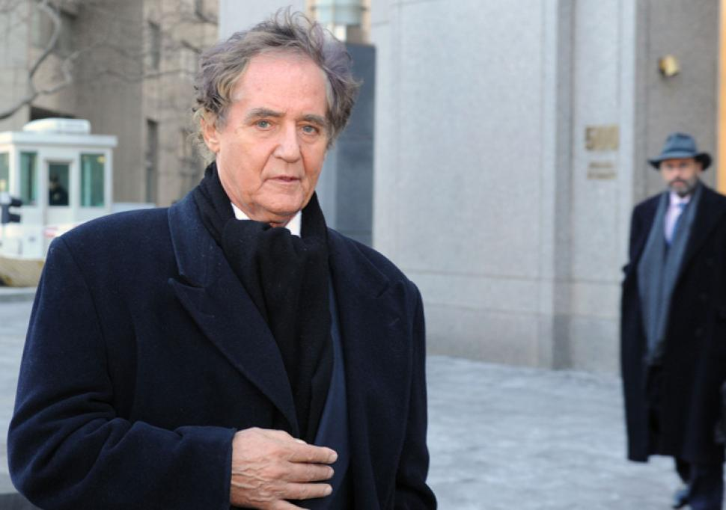Bryan Smith for New York Daily N

Dr. Niels Lauersen
A former Park Avenue gynecologist to the stars who did jail time for insurance fraud is a leading player in a challenge to an Upper East Side heiress’ $8 million will.
Niels Lauersen, 74, a onetime fertility specialist known as the “Dyno Gyno” whose patients included Celine Dion and Liv Ullman, was a witness to the will — drafted by Lauersen's own matrimonial lawyer.
It gives Robin Archer Moles' entire estate to her health aide, Lauersen’s pal.
Moles, whose grandfather founded the food conglomerate Archer Daniels Midland, was a former theatrical producer. She died in February 2009 at 70.
Her nephew Christopher Ljungkull, a Minneapolis businessman who was Moles' prime heir in a 1974 will, argues in court papers that his aunt was a daft and frail alchoholic when in her last will, made in 2007, she left everything to her aide, Elsie McCarthy, 67.
The Appellate Division in Manhattan this week overturned a Surrogate Court judge’s decision to throw out the nephew's objections and ordered a trial on the validity of Moles' 2007 will.
Ljungkull and his lawyer, Jeff Ross, declined to comment, and Lauersen did not return phone calls.
In an interview at her apartment door on E. 97 St., McCarthy said Moles knew what she was doing.
"She was very, very smart. I loved her like a mother. I worked 24/7, 12 months of the year. We traveled all over the world together - - Ireland, Paris, London, Atlantic City. "
McCarthy blasted Moles' nephew for disparaging her.
"I'm not shanty Irish. I come from royalty," she said. More specifically, McCarthy said she comes from West Cork, where "I have three houses. They’re all on the water."
Earlier this year, Ljungkull’s lawyer, Ross, raised questions in court papers about the will and about $140,000 in checks written on Moles’ account to Lauersen and McCarthy.
Court records show that Lauersen received or endorsed 86 checks worth $50,900 in Moles' final years, while McCarthy got $94,022, some of which paid her rent and utility bills.
McCarthy's lawyer, Ira Turret, said there was no proof that this money was stolen. He said some checks were gifts, while others were reimbursements for money spent on Moles’ behalf.
Lauersen, a millionaire with three Park Avenue co-ops, was convicted a decade ago for lying to insurance companies about procedures he never performed. He told lawyers that when he got out of prison, stripped of his medical license by New York State, Moles paid him to feed her cats and walk McCarthy’s dog.

Court files show that Jeffrey Suazzo, a videographer who filmed the 2007 will signing, told lawyers that Moles was "not there" mentally that day. "The lights are on but there's no bulb," he said.
A transcript of the videotape shows Moles slightly confused about the date and the name of the President .
Moles said she was leaving her money to McCarthy "because I adore her,” according to the transcript.
The appellate judges said any trial would explore why a psychiatrist from the city's Adult Protective Services agency concluded in 2007 that Moles needed a guardian.
The city psychatrist, Dr. Ralph Speken, found that Moles had short-term memory loss and couldn't do basic arithmetic.
McCarthy, who said she is fighting cancer, said she looks forward to getting her inheritance “so I can do the things that Robin wanted - like open soup kitchens.”

