I Stopped Delivering Babies So That I Can Provide Abortions
In the Southeast there are plenty of folks providing high quality obstetrics care, but not nearly enough providing high quality abortion care.

Nicole Fanarjian
Mar 31, 2015

I stopped delivering babies so that I can provide abortions. This is probably something you haven’t heard very often. It is also not something I have said out loud very often.
I love delivering babies. I never wanted to give it up. And yet I’ve found myself in a place where I had to make a choice no obstetrician/gynecologist (ob/gyn) should have to make: provide care for women who deliver babies, or provide care for women who need abortions, just not both.
I am an ob/gyn who cares deeply about gender equality and reproductive justice. I believe that doctors in my specialty should be willing and able to perform abortions for their patients; this is part of basic reproductive health care. After all, one in three women will have an abortion by the time she is 45. This is not just someone you know; it’s someone you love – your sister, mother, best friend, maybe even you.
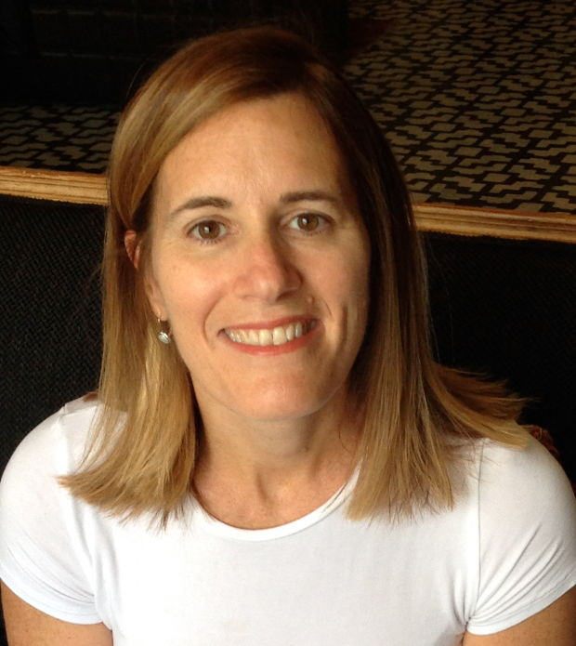Nicole
Unfortunately, I have found this is not always easy to do. I encountered obstacles to learning about abortion in medical school, to getting trained in how to provide abortions in residency, and to integrating abortion care into my ob/gyn practice.
As a medical student in the Northeast, I was actively involved in Medical Students for Choice (MSFC), a non-profit organization that aims to improve medical student education about abortion. We had our work cut out for us. While the hospital where I rotated ‘permitted’ abortions, the other affiliated hospital, where some of my classmates rotated, was a Catholic institution that prohibited them. It was pure chance whether or not students would be able to participate in abortion care in our medical school. It didn’t matter if you wanted to learn it or not; it was left up to chance.
I remember wondering how odd it seemed that such a common procedure (more common, at that time, than C-sections) was not uniformly taught in medical school. We learned so many esoteric things; it seemed wrong not to teach something so basic. I thought at first that perhaps my med school experience was unique, but when I spoke with students from other schools I learned that my experience was not at all unusual. Abortion was considered to be so ‘controversial’ that at some schools students weren’t even allowed to organize an official MSFC campus group.
Things didn’t get much easier once I started my ob/gyn residency, which brought me to the southeastern United States. My program offered limited abortion training despite being an academic medical center affiliated with a large non-profit hospital where there was a significant need for abortion care. I was told that years back a nearby abortion clinic trained some residents, but this, supposedly, incited picketers and other unwanted publicity for the hospital.
It shocked me that a few protesters — or really, cowardice — could lead the hospital administration to decide that it was okay for residents to not be taught a relatively simple procedure that so many of their future patients would need. I didn’t want to make waves and learned where I could send my patients who needed abortion care. And instead of being deterred, I became ever more determined to provide full-spectrum ob/gyn care, including abortion, after residency.
Unfortunately, working at a federally qualified health clinic in the rural Southeast to repay a med school scholarship obligation after residency again restricted the care I could provide. At a clinic receiving federal funds, I was ‘gagged’ and not permitted (or so I was told) to discuss, let alone perform, abortions.
I recall one patient in particular who needed an abortion at 20 weeks in order to save her life. Legally speaking, I probably could have provided her with the care she needed given that her life was in danger, but I had to confront the fact that I was not adequately trained to provide this care. More than anything, I felt helpless and ashamed that I had to send this patient to another doctor to save her life.
Advertisement — Continue reading below
Unwilling to live with this shame, I sought and completed a women’s reproductive health fellowship under the tutelage of one of the world’s leading abortion experts. I learned how to provide compassionate and skilled abortion care up through 20 weeks gestation and integrated this care into my practice of general ob/gyn and research. It was like manna from heaven: my ideal job.
After finishing my two-year fellowship, my husband’s job took us back to the city where we trained and I found myself back at square one: unable to find a medical practice that would allow me to provide comprehensive reproductive health care.
I had to choose: Either be a general ob/gyn who delivers babies – which I loved doing – but who is not allowed to provide abortion care; or become a gynecologist who provides abortion care. I chose the latter.
Despite years of training and a passion for obstetrics, I decided to stop delivering babies so that I could provide abortions. I could no longer turn my back on the patients who need abortion care. In the Southeast there are plenty of folks providing high quality obstetrics care, but not nearly enough providing high quality abortion care. I took a job as an abortion provider.
I am also committed to training future doctors in the way I was trained in fellowship, so I work with my residency program and its medical school to train residents and medical students in abortion care. One of the first things I tell them about is the case of a young woman in a suburban area in the Southeast who died because her ob/gyn was not trained to perform an abortion at 14 weeks. In 2015, no woman in the United States should have to die because her doctor(s) can’t perform this common procedure. When personal beliefs and politics limit what doctors are taught, our patients suffer unacceptable consequences.
I have come to believe that abortion care is such an integral part of our specialty that those who join the specialty ought to be trained and required to provide this care.
At the same time, I recognize and admit that dealing with the stigma and emotional toll attached to being an abortion provider is not always easy. A mentor once described the emotions of providing abortion care as a means of relieving a woman's burden of suffering. What I took him to mean is that by providing abortion care I am helping my patient get on the other side of this difficult experience with dignity and support. I am suffering, if you will, to enable her to suffer less.
In addition to being emotionally charged work, abortion is of course highly politicized and stigmatized. My decision in recent years to provide and teach abortion care has cost me professional opportunities. On a personal level, my family and friends have thankfully not yet been targeted. My name and image do feature prominently on an anti-choice website so I have real concerns about this.
In many ways, however, I still consider giving up obstetrics to be my biggest sacrifice to do this work. I was good at it and derived immense satisfaction from it. The process of delivering a baby was a rush. It was difficult to decide not to do this and I am continuing to try to figure out a way to integrate obstetrics into my practice again. But unless and until more health care providers decide to integrate abortion care into their practices, I will continue to fill this gap.
Participating in obstetrics care is often joyous, whereas ending a pregnancy is often not. Those of us who choose to assist women in this way do it because we can't imagine not doing it. We think it is unethical to do otherwise. We do it, not because it is glamorous or because we expect to be glorified, but because we care deeply about women and trust their family planning decisions.
Today, after five years of being an abortion provider, I find that I'm good at providing abortion care and derive immense satisfaction from it. No longer do I need the rush of delivering babies. Instead I seek balance and am reminded that any personal sacrifice I have made pales in comparison to those of my patients. I am humbled and honored to be their doctor.
Nicole Fanarjian

Original article found online at: http://www.xojane.com/issues/i-gave-up-delivering-babies-so-i-could-provide-abortions

