OH HELL NO
5/10/16 5 PM

Meet the abortion doctor who just said F-you to the system
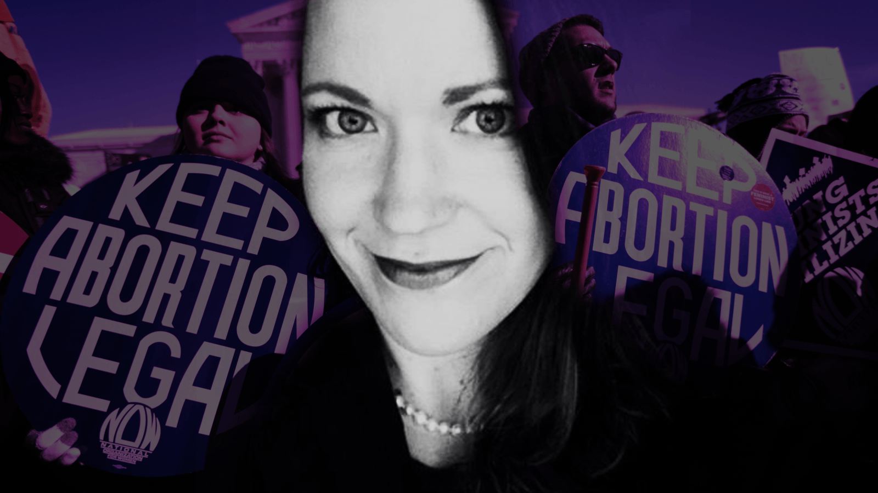
Courtesy of Dr. Jennifer Conti, Getty Images

Jennifer Conti
Dr. Jennifer Conti is an OBGYN physician at Stanford University who specializes in family planning. She is also a medical journalist who trained at the Columbia Graduate School of Journalism.
---
Many women’s health advocates wear their passion on their sleeve. Diane Horvath-Cosper wears hers on her ankle, in the form of a coat hanger tattoo—a reminder to herself and others, she says, that our country is rapidly returning to the dark ages of abortion and the horrors this reality entails.
I know about Horvath-Cosper’s tattoo because I was with her when she got it last month. After we left the tattoo studio, she promptly Instagrammed a photo of it with the hashtag #NeverAgain, then turned to me and said, sarcastically, “My parents are going to love this.”
As a fellow OBGYN and a friend of Horvath-Cosper’s, I was proud but not at all surprised when she announced, in a mic-drop moment last week, that she was taking legal action against her hospital for forbidding her to speak publicly about her work and beliefs as an abortion provider.
As The New York Times first reported, Horvath-Cosper is filing a civil rights complaint against MedStar Washington Center Hospital in Washington, D.C. for what she describes as a “gag order” that has essentially put the kibosh on her work as an abortion rights advocate. “I don’t think the way to deal with bullies is to cower and pull back,” she told the paper.
Not surprisingly, news of Horvath-Cosper’s decision temporarily broke the internet—or at least that sliver of the internet reserved for abortion news, making her an overnight feminist heroine.
It also confirmed what I have long known of my friend: Diane Horvath-Cosper is a badass. She’s the friend you’d want standing behind you if you were ever to get into a bar fight. She’s the woman you’d pick to be your Olivia Pope. Never have I met a more brilliant, beautiful, and inspiring human being. And while the “gag order” still prevents her from speaking out, I feel compelled to speak out in support of her—because the precedent she is setting for fellow abortion providers like myself is nothing short of tremendous.
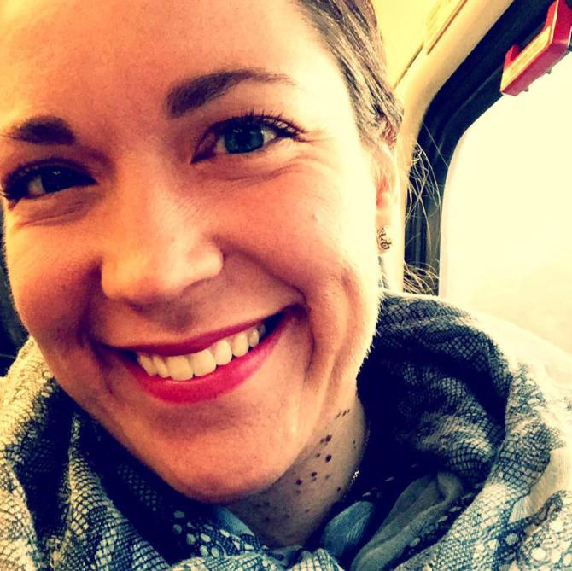Twitter Tweet Facebook Share Pinterest Pin It Copy image
Courtesy of Dr. Jennifer Conti
Thanks, Diane.
I first learned about the hospital’s “gag order” last fall, when Diane sent me a frantic series of texts, brimming with outrage and comically timed F-bombs. “You’re never going to believe this bullshit!” she texted me. “The hospital is telling me I can no longer interact with the media. They said they didn’t want to advertise that they did abortions here and that my media presence was like a big Kmart blue light special.”
The timing couldn’t have been worse. In addition to being friends, Diane and I are co-fellows for Physicians for Reproductive Health’s Leadership Training Academy, a program that trains abortion providers in media and legislative advocacy. Word had just spread of a crazed anti-abortion terrorist shooting up the Colorado Springs Planned Parenthood; The Center for Medical Progress was still falsely alleging that abortion clinics sell baby parts for cash; and Republican presidential candidates were competing to see who could spew out the most extreme anti-choice propaganda. Now was the exact moment we needed Diane’s voice.
When Diane started talking about enlisting lawyers, her department heads told her to forget it—saying this kind of pushback would bring nothing but bad press for the hospital and probably lead to her being fired. At the time, she recounted one of the head hospital personnel telling her, “I wouldn’t do that if I were you,” which, to Diane, translated as, “Bring it on, bitches.”
There is a real vulnerability that comes with this line of work. You have to be brave enough to endure people calling you bad names and intrepid enough to keep fighting.
That’s Diane—a fierce but hilarious doctor, mother, and friend. From what I’ve heard, even as a kid, she was a ball of fire. She once told me she wasn’t surprised her own daughter was so sassy because she herself had been the shit-stormiest of all the kids in her large Catholic family. Her Catholic upbringing, by the way, may be the most ironic part of her story. How does a good Catholic girl grow up to be abortion doctor superstar? She’s still not sure.
But growing up Catholic has also led to alienation by friends and family. Diane often refers to fellow abortion providers as her “family planning family,” a testament to the support we offer each other. Indeed, when my own father recently unfriended me on Facebook for being “too vocal” about my views, it was Diane I texted first. Sometimes a lack of support from those closest to us can feel more hurtful than a protester’s nasty comments or even a legislator’s efforts to restrict abortion access. I knew she’d understand.
In reporting this story, Fusion reached out to MedStar for comment. The hospital responded with a written statement, saying, “Like many hospitals across the nation, we offer [family planning] services discreetly to ensure that our patients can have a professional, respectful, confidential, and safe environment in which to receive care.”
The hospital went on to note that it had asked Diane to “step back from her high-profile approach” because it believed it put patients and staff at risk. The statement also noted, “While we respect her personal beliefs, we find it misguided that she chose to file a complaint with the federal Office for Civil Rights (OCR). Although the document alleges that we threatened to dismiss her, this is not the case, and she remains employed with us. If OCR chooses to pursue this complaint, we will cooperate fully with them.”
There is a real vulnerability that comes with this line of work. You have to be brave enough to endure people calling you bad names and intrepid enough to keep fighting for the millions of women who need but cannot properly access reproductive health services. Some of us do it publicly through advocacy; others of us work behind the scenes, providing care in the reddest parts of this country, where abortion is becoming all but extinct. This is why Diane is putting herself out there—because she is strong enough to do this work and do it well.
Is filing a very public complaint what it takes to challenge a hospital system that is, at best, not anti-choice but also not truly pro-choice? Yes—and if we as a community of abortion providers were going to call on any one person to rise to this challenge, it was always going to be Diane.
TWEET SHARE EMAIL

Story Tags
Tags
- Sex & Life
- Health
- Women
- Politics
- Media
http://fusion.net/story/298994/diane-horvath-cosper-abortion-doctor-advocate-complaint/

