FacebookYouTubePinterestEmail
Call Us Today! 505.843.6168
Original document found online at: http://wsnm.org/qa-with-rebecca-leeman-cnm-and-stephanie-philippides-md/

Q&A with Rebecca Leeman, CNM and Stephanie Philippides, MD
Home/Education/Q&A with Rebecca Leeman, CNM and Stephanie Philippides, MD
These two lovely ladies are Rebecca Leeman, CNM, and Stephanie Philippides, MD. They are located at our Jefferson office and attend births at Lovelace Women’s Hospital and I recently asked for their thoughts about how WSNM approaches pregnancy and birth.
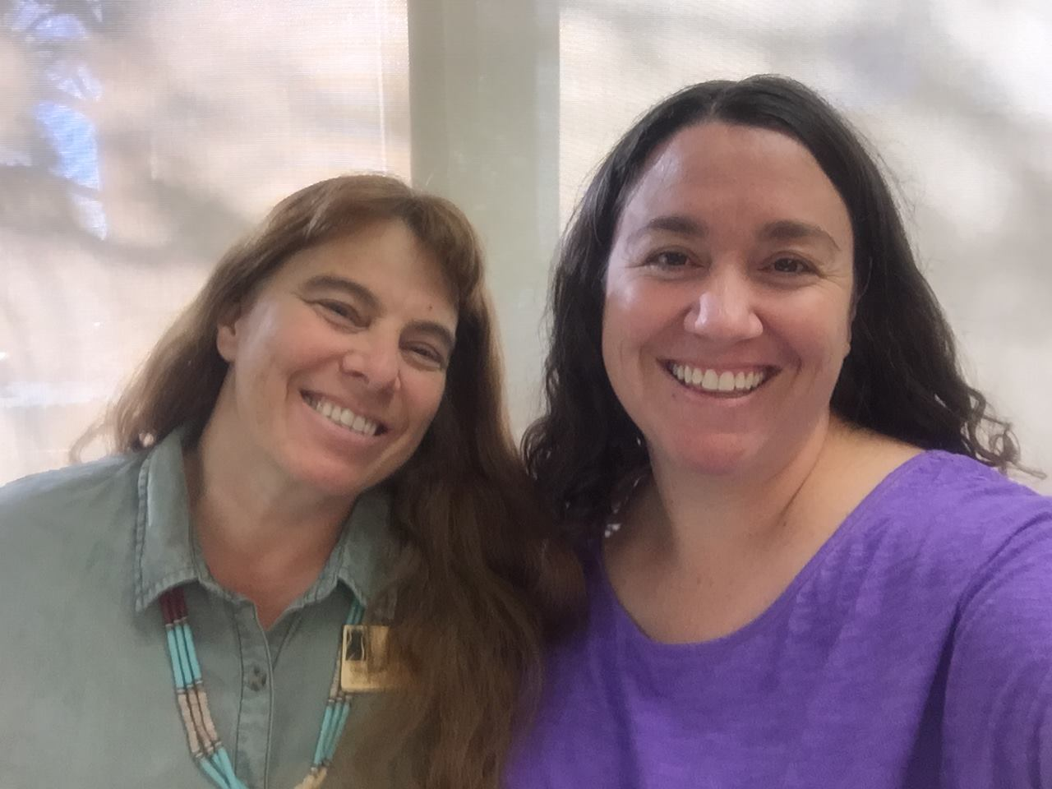

Q: What does personalized pregnancy care mean to you?

Q: What sets WSNM apart as a practice?

Q: Why did you decide to work as a midwife or OB?

There you have it! Thoughts on pregnancy, birth and WSNM from two of our awesome providers.
Cheers,
Jen Williams, CNM
February 5th, 2016|Education|Comments Off on Q&A with Rebecca Leeman, CNM and Stephanie Philippides, MD

Locations
Downtown
201 Cedar SE, Suite 5640
Albuquerque, NM 87106
Jefferson Lane
4640 Jefferson Lane NE
Albuquerque, NM 87109

Contact
Phone: 505.843.6168
wsnminfo@wsnm.org

Westside
6320 Riverside Plaza Lane NW, Suite A
Albuquerque, NM 87120
Oasis Med Spa
101 Hospital Loop NE, Suite 105
Albuquerque, NM 87109

Sitemap
Patient Portal
Privacy | HIPAA
© 2011 - 2016 Women's Specialists of New Mexico, LTD. | Web Development by: Reactive Consulting
FacebookYouTubePinterestEmail

